
Immediate 6 November 2015

NIGHT OF GOLD WINNERS AT LEICESTER AND LEICESTERSHIRE EXCELLENCE IN TOURISM AWARDS

13 Gold award winners including local hotels, festivals, visitor attractions, restaurants, arts centres, B&Bs, pubs, conference centres and self catering accommodation

Gold awards were presented to 13 tourism businesses at the fifth annual Leicester and Leicestershire Excellence in Tourism Awards 2015. Gold winners and Highly Commended finalists received their awards at the ceremony on 5 November 2015, hosted by Leicester Shire Promotions and held at Mercure Leicester, The Grand Hotel.

The winners in each category were:

Accommodation Provider of the Year
- Mercure Leicester, The Grand Hotel - Gold
- Kilworth House Hotel - Highly Commended
- Best Western Plus Ullesthorpe Court Hotel & Golf Club - Highly Commended

Tourism Event of the Year
- Melton Mowbray Victorian Fayre - Gold
- Foxton Locks Festival - Highly Commended

Small Visitor Attraction of the Year
- Bosworth Battlefield Heritage Centre - Gold
- Stoneywell - Highly Commended
- The Boilerhouse - Highly Commended

Taste of England Award
- The White Peacock - Gold
- 34 Windsor Street - Highly Commended
- National Space Centre - Highly Commended

Large Visitor Attraction of the Year
- King Richard III Visitor Centre - Gold
- Curve - Highly Commended
- National Space Centre - Highly Commended

Access for All Tourism Award
- Attenborough Arts Centre - Gold
- National Space Centre - Highly Commended

Sustainable Tourism Award
- Horseshoe Cottage Farm - Gold

Tourism Pub of the Year
- The Belper Arms - Gold

Business Tourism Award
- imago - Gold

Tourism Experience
- King Richard III Reinterment - Gold
- Hawkwise Falconry - Highly commended

Holiday Park of the Year/Self Catering Provider of the Year
- Eye Kettleby Lakes - Gold
- The Dandelion Hideaway - Gold

Bed and Breakfast Award
- Badger’s Mount – Gold

Winners on the night will now be re-judged for the national VisitEngland Awards for Excellence 2016. In the 2015 VisitEngland awards, four local businesses made it through to the finals including Gold Award winner, Hotel Maiyango, as well as The Dandelion Hideaway, The Exchange and the National Space Centre.

Martin Peters, Chief Executive of Leicester Shire Promotions said: “This year’s finalists, Highly Commended and Gold award winners, showcase the strength of Leicester and Leicestershire’s offering as a nationally-recognised destination for domestic and international visitors. We’re proud of all of these local businesses, organisations and experiences, and will be supporting them as they aim for national glory in the VisitEngland awards.”

James Berresford, Chief Executive of VisitEngland added: “This year’s finalists are fantastic examples of local businesses that are creating memorable experiences for visitors to Leicester and Leicestershire. I wish them the very best in competing for our VisitEngland Excellence awards in 2016.”
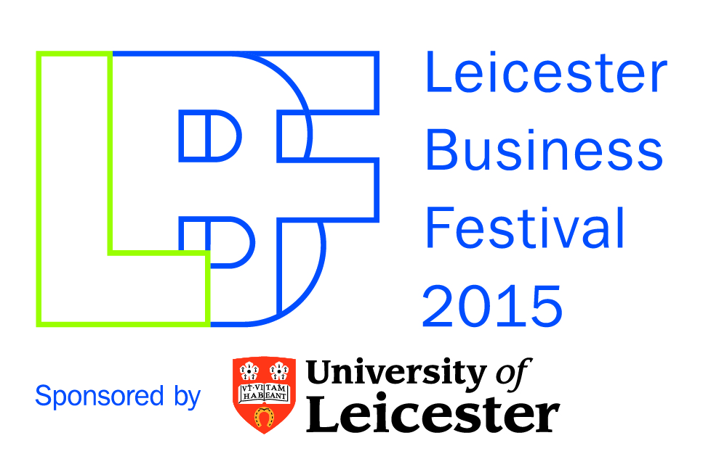
The Excellence in Tourism Awards are part of this autumn’s inaugural Leicester Business Festival (LBF). LBF runs from 26 October to 6 November 2015 and was instigated by the Leicester and Leicestershire Enterprise Partnership (LLEP), a business-led partnership between the public and private sector looking to drive economic growth across the region. For more details, visit http://leicesterbusinessfestival.com

About Leicester Shire Promotions:
Leicester Shire Promotions is the tourism organisation for Leicester and Leicestershire. The company works in partnership with Leicester City Council, Leicestershire County Council, the Leicester and Leicestershire Enterprise Partnership, VisitEngland and the local tourism industry to deliver campaigns and services to attract more visitors to the city and county. For more information, go to www.visitleicester.info or www.goleicestershire.com, or follow us on Twitter at @l_p_l

For further media information, please contact:

Simon Gribbon
Leicester Shire Promotions
T: 0116 225 4001
simon.gribbon@l-p-l.com

LPL740-15

